## Recap

Lot of devices, people even in some case animal are being attached to internet every day, with unique identifiers and the ability to transfer data over a network without requiring human-to-human or human-to-computer interaction for the development of independent cooperative services and applications. The main idea is to connect the physical world with the digital world. IoT is improving processing capability and connectivity, decreasing size, creating opportunities for new application. Despite of these benefits still there are the questions about privacy, ecosystem formation, effective communication and data management. IoT has three main visions, things oriented vision, Internet oriented vision, semantic oriented vision.

In IoT high level architecture core structural elements are different devices (identifier, sensor/actuator, embedded system), Gateway device, Application platform, Application, possible constrain of these devices are limited computational power, memory, battery power; limited or no UI, etc.. Based on used wireless technology they can be divided into two major group, short range and wide range technology. Wifi, bluetooth, ZigBee etc. goes under short range where as GPRS, WiMAX, CDMA, LTE represent wide range.

From business perspective IoT is growing value in automatic identification and tracking, remote state monitoring etc sector. For example Vehicle tracking, RFID passports, environment monitoring, community pothole detection, remote healthcare monitoring. By the year 2020 Gartner will instll 26 Billion devices, Ericsson will install double of that by 2025. Gartner's revenue will hit $300B by 2020 while total impact from IoT would be $1.9T. To get ultimate success we need to overcome some challenges too. Data traffic patterns will be different from the current Internet so it is necessary to define new QoS requirements and support schemes, security mechanisms need to be rearranged, currently there is no standard infrastructure/middleware therefore, making the costs of IoT solutions high, business models are not available, efficient partnerships and ecosystem formation is still a challenge. According Moore business ecosystem is the network of buyers, suppliers and makers of related products or services; socio-economic environment and institutional and regulatory framework. Different segments may host different ecosystems e.g. government agencies, stakeholders, organizations with shared products and service.

# Perception:

we see the use of network based RFID has been increasing everywhere. In super shop like Prisma, K citymarket are using RFID tag for preventing Burglaries. Burglar alarm is also connected to network for prompt action from police or security companies. House hold fire alarms are connected to local fire station.

## Criticism:

While everything is connected to the internet it is always a big concern to be hacked or abused. According Brian Clark Howard 1 "It’s obvious that military agencies will need to make sure that missiles and other systems of war aren’t hijacked by hackers. But what is the risk of your neighbour turning your toaster against you?". There is huge controversy in south Asia about use of Electronic Voting Machine (EVM) as it can be hacked. The U.S. National Intelligence Council produced a report 1 in 2008 that warned it would be hard to deny "access to networks of sensors and remotely controlled objects by enemies of the United States, criminals, and mischief makers."

## Deepening:

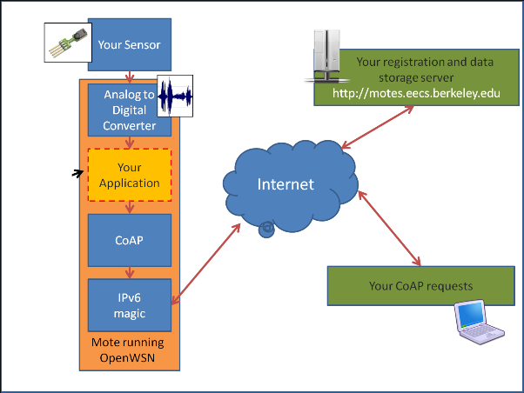Constrained Application Protocol (CoAP) is an application layer protocol to be used in low power sensors, switches, valves and similar components that need to be controlled or supervised remotely, through standard Internet networks. For Internet of Things (IoT) and Machine-to-Machine (M2M) communication simplicity are very important. CoAP is designed to easily translate to HTTP for simplified integration with the web.

The main features of CoAP are:

* Minimizing the complexity of mapping with HTTP.
* UDP binding with reliability and multicast support.
* Low header (10-20 bytes) and parsing complexity.
* URI and content-type support.
* Asynchronous information push enables the smart objects to send information about the resource only when it changes, therefore device can be in hibernate.
* Simple caching

# Reference:

1. http://redicecreations.com/article.php?id=26813

Khandker, Syed Ibrahim

WISE